Students’ Achievements for Website
Innovation
- The Mechanical Pendulum Pump - An Innovative Design of a Hand Pump to Transport Water In Hilly Areas - amongst the TOP 3 Projects at the CBSE National Science Exhibition out of 447 projects from 377 schools.
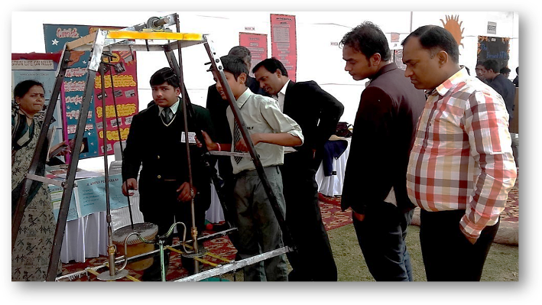
- CSIR Innovation Award 2012- Won the National CSIR Innovation Award and a cash prize of ₹50,000 for developing ADIA-COOL, a low-cost, eco-friendly air conditioner.
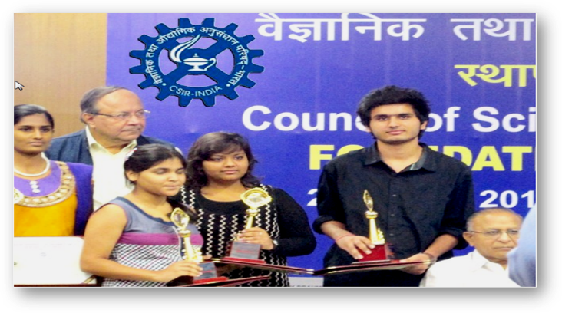
- CSIR Jigyasa Epic Hackathon 2024 - Out of 1000 projects, Delfites won Silver and ₹30,000 for scientific innovation DRISHYAMITRAM that helps visually impaired individuals to navigate public spaces independently.

The innovators also worked for the project at the incubation center provided by the Ministry of Science and Technology.

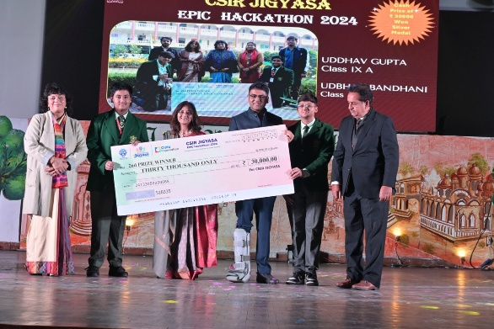

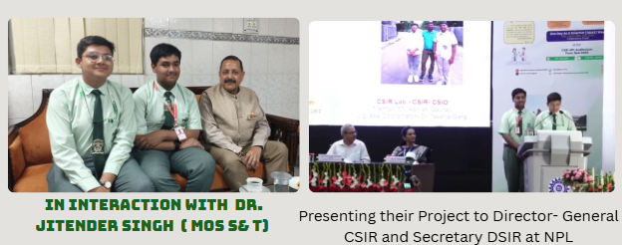

- Project Therophonobot – Therophonobot earned national recognition amongst 108 state-level entries, at INSPIRE MANAK and secured a prestigious USD 7,500 innovation grant from Emergent Ventures, USA.

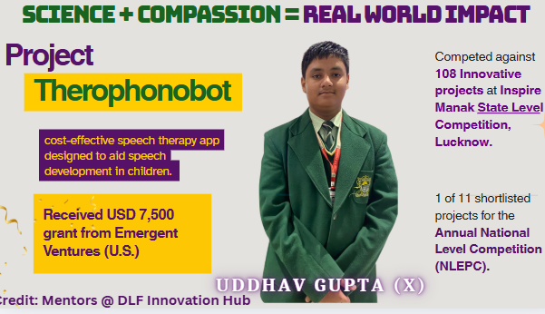

- Mission Talaash – Lost & Found Mobile App (2015) Ranked among India's Top 20 innovations out of 2,512 entries from 27 states for developing ‘Mission Talaash’, a Lost & Found mobile application.
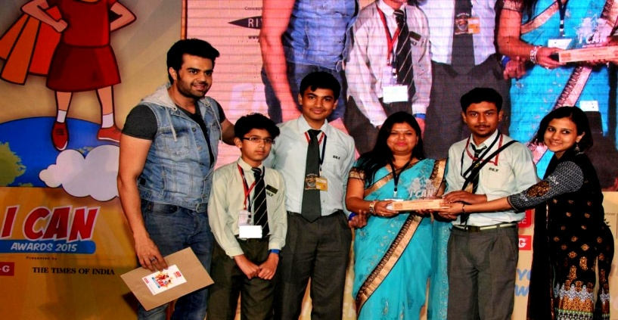
- Unique Hospital Bed - 1st Position at Crossroads 2015 for creating a patient-centric hospital bed equipped with automated care, in built toilet and hygiene features.
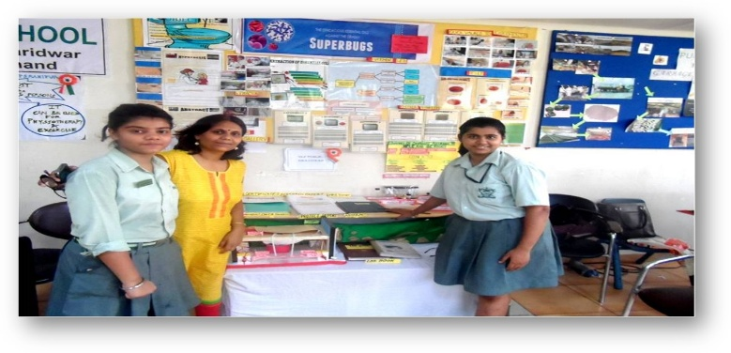

- 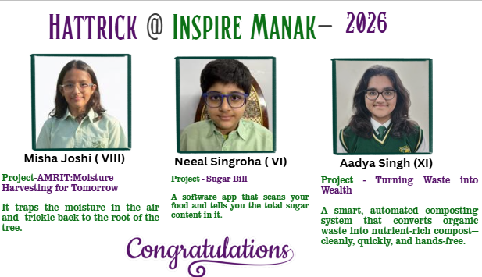
Project Hornbill stood 2nd at World Robot Olympiad

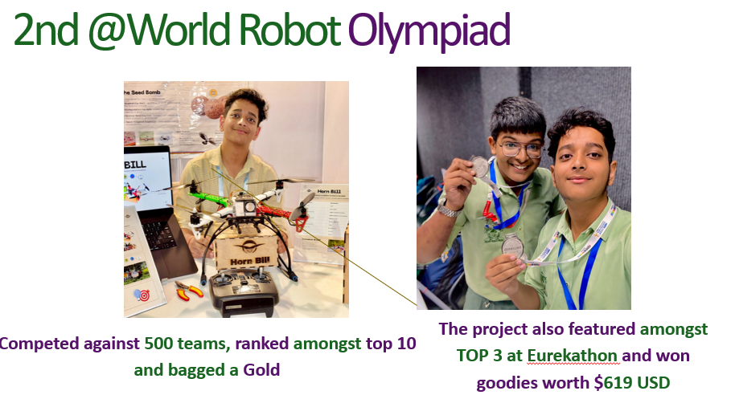

Aditya Tripathy and Prajesh Nair (XII) competed against 500 teams, ranked amongst top 10 and bagged a Gold. The project also featured amongst TOP 3 at Eurekathon and won goodies worth $619 USD.
Commerce
- University of Melbourne India Case Competition 2025 - Ranked 2nd and earned AUD 1,000 at the Grand Finale, competing against 350+ teams Nationally.
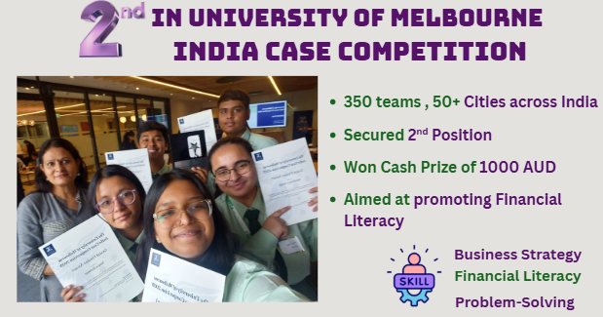
- International Commerce Olympiad - Two Years. Two Wins @ International Commerce Olympiad
2024- Ananya Trivedi became the second Runner up
2025- Gaurangi Mittal became the first runner up , won a trophy and Cash prize.

Sports

- Ishika Singh - Delfite Ishika Singh played at Delhi Premier League as an All rounder and played for the team South Delhi Superstarz.
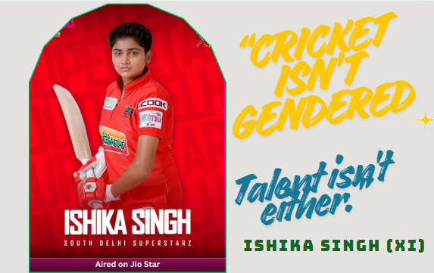
- Shree Singh at UP State Championship broke two of her best records, won 5 Gold Medals, creating 5 New State Records, and earning the coveted title of Best Swimmer.
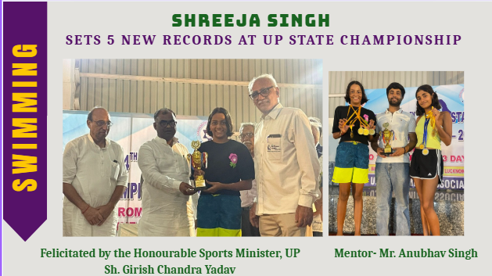
- Priyanandini Thakur bagged 4 Gold at CBSE North Zone Swimming Championship
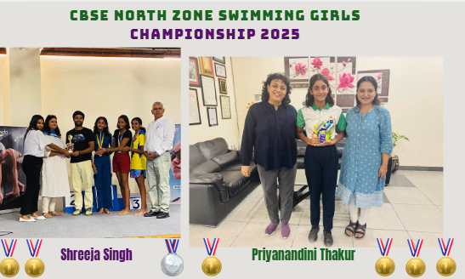
- Nandini Kansal represented India @ ITF Nepal and Africa , AITA ranking #21 ( in UP) and #184 (under 18 girls) in India.
- Uday Kaul represented India at the prestigious ITF (International Tennis Federation) Tournament held in Kazakhstan . AITA men’s Ranking 262
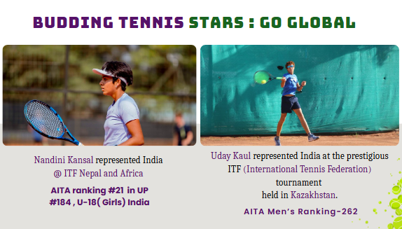

- Silver and Gold in various categories at District Tennis Championship
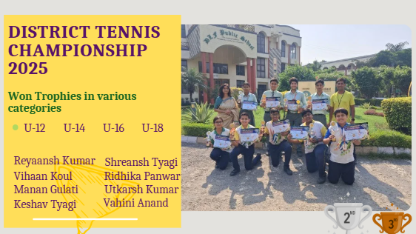

- Bronze at CBSE North Zone Tennis Championship in various categories.
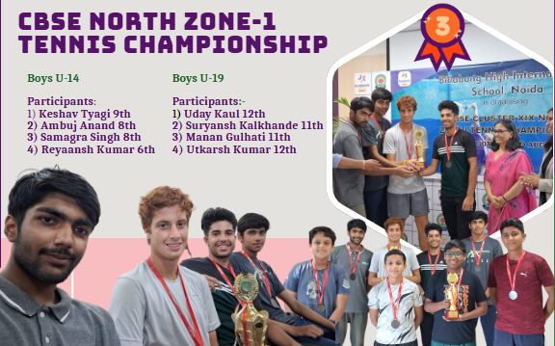
- Suryansh Kalkhande of class XI Won AITA National Ranking Tennis Tournaments in the Category - U-18 Doubles
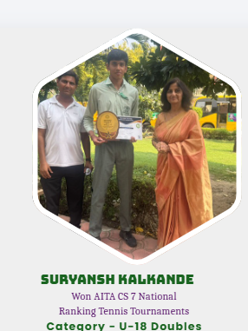

- Anirudh MM bagged Gold at State Yogasana Sports Championship 2025
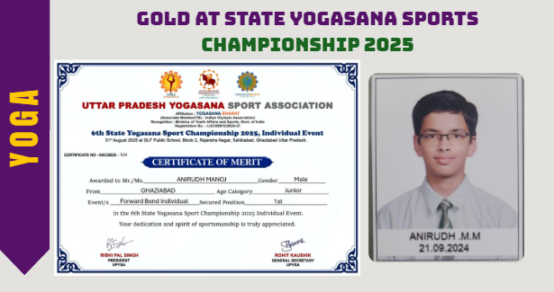

- Delfites clinched 1st and 2nd position in various categories at 5th District Yogasana North East Championship.

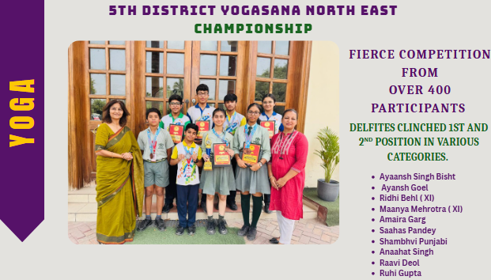

- Bagged 2nd position at Ghaziabad District Roll Ball Championship
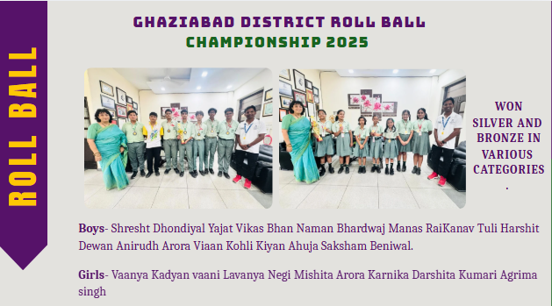

- 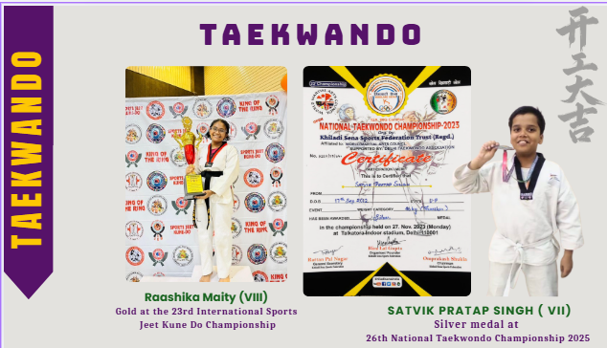

- Anushka’s Nari Shakti Moment- Anushka Dhama of class XII became an SHO for a day at the newly inaugurated Shalimar Garden Police Station
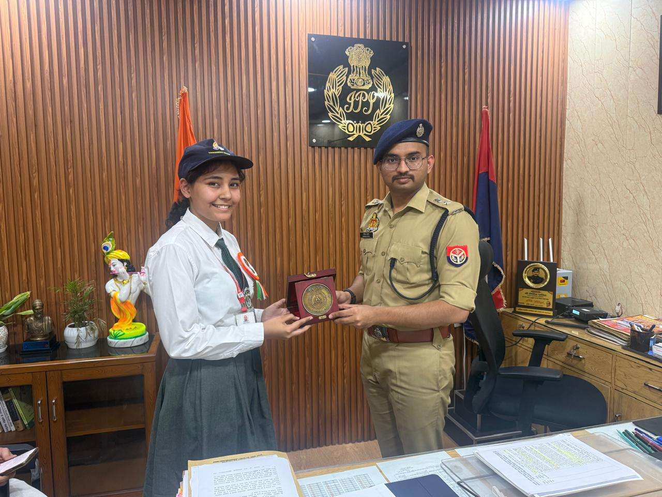

Performing ART
- 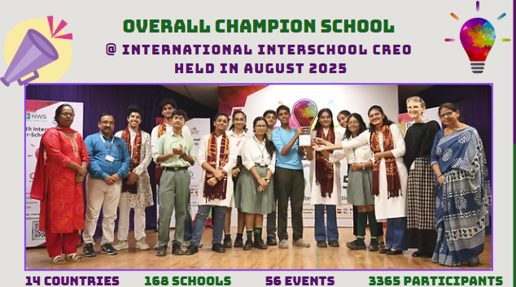

- 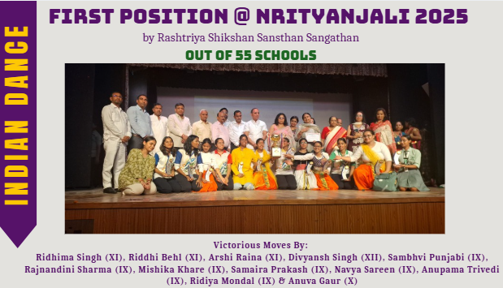

- 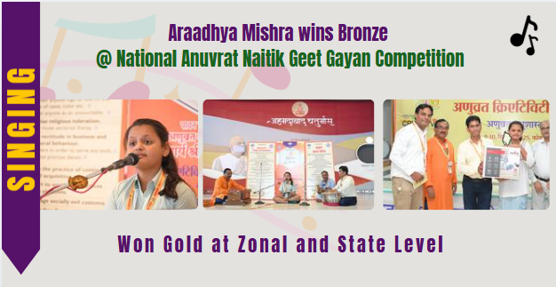

- 90+ Delfites have acted in 35+ NCERT Educational Videos
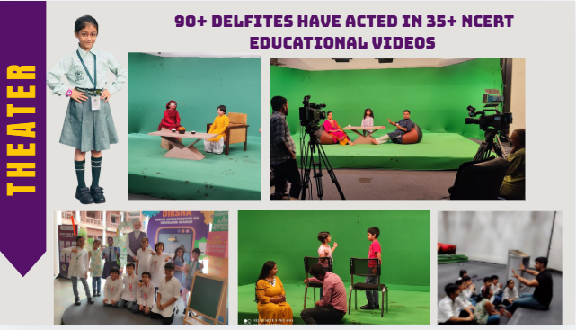

Literary
- Overall Winning trophy @ Ramjas Inter School Extempore Competition

